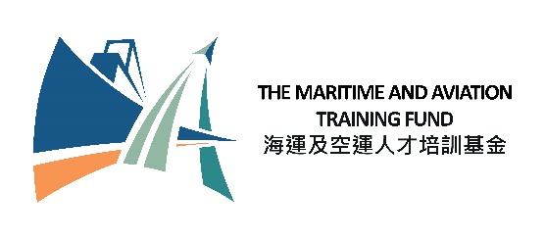

**Maritime and Aviation Training Fund**

**Internship Scheme on Modern Logistics**

**Registration Form for Internship Positions (2025-26)**

**Please submit this form by -**

***Fax: 2523 0030 or***

***Email:*** [***internship_logistics@tlb.gov.hk***](mailto:internship_logistics@tlb.gov.hk)

**To: Maritime and Aviation Training Fund**

**Transport and Logistics Bureau**

**Part A: Company Information**

|  |  |
| --- | --- |
| **Company Name** |  |
| **Contact Person**  **(e.g. Human Resources Officer)** | **Name:**  **Post title:**  **Tel. no.:**  **Email Address:** |
| **Company Address** |  |
| **Business Registration Number** |  |
| **A brief introduction of the company and description of the business activities that are relevant to modern logistics** |  |
| **Objective(s) of Internship to be Offered** |  |
| **Number of Intern Position(s) to be Offered[1] [Up to 10 interns per financial year]** |  |

**Part B: Information for Advertising the Registered Intern Positions under the Internship Scheme on Modern Logistics**

|  |  |  |  |  |  |  |  |
| --- | --- | --- | --- | --- | --- | --- | --- |
| **Company Name  and  Company Website** | **No. of Intern Places** | **Main Job Duties**  *(Please specify the  modern logistics-related job duties)* | **Internship Period[2]**  *(minimum 4 weeks, i.e. 28 days)*  *e.g. dd/mm/2025 – dd/mm/2026* | **Monthly/ Daily/ Hourly Honorarium to Intern**  *(HK$/Intern)* | **Specific Requirements**  **(if any)**  **e.g. area of study /**  **skill / language** | **Application Deadline**  *(A specific date or open until filled)* | **Application Method** |
|  |  |  |  |  |  |  |  |
|  |  |  |  |  |  |  |  |
|  |  |  |  |  |  |  |  |

**Part C: Declaration**

I have read, understood, and undertake to comply with the following clauses:

1. the Government reserves the right to disqualify this registration on the grounds that the participating company has engaged, is engaging, or is reasonably believed to have engaged or be engaging in acts or activities that are likely to cause or constitute the occurrence of offences endangering national security or otherwise the exclusion of the participating company from future registrations is necessary in the interest of national security, or is necessary to protect the public interest of Hong Kong, public morals, public order or public safety; and
2. even after the registration is approved, the Government may immediately withdraw or cancel the relevant approval, and the participating company has to repay to the Government all the monies received in connection with the registration and the Government reserves the right to recover by civil action and the participating company may be liable to prosecution, upon the occurrence of any of the following events:

* the participating company has engaged or is engaging in acts or activities that are likely to constitute or cause the occurrence of offences endangering national security or which would otherwise be contrary to the interest of national security;
* the continued disbursement to the participating company is contrary to the interest of national security; or
* the Government reasonably believes that any of the events mentioned above is about to occur.

**Official Company Stamp**

|  |  |
| --- | --- |
| **Signature of Authorised Person :**  ***(For and on behalf of the company)*** |  |
| **Name :** |  |
| **Position :** |  |
| **Telephone No. :** |  |
| **Email :** |  |
| **Date :** |  |

1. Companies are free to select suitable intern(s) and have no obligation to fill all registered intern position(s). However, companies are encouraged to fill all the registered positions as far as possible.
2. The valid internship period cover one financial year *(i.e. from April this year to March next year)*.